CSE446/598
Hypermedia Services Assignment
ReadMe
Shihuan Shao
- Released the projects from the zipped package to a folder called HATEOAS-Appeals-<sshao1>-<NetBeansIDE-7.3>
- Click Open Project Button, enter corresponding directory, and open the AppealClient and AppealServer.

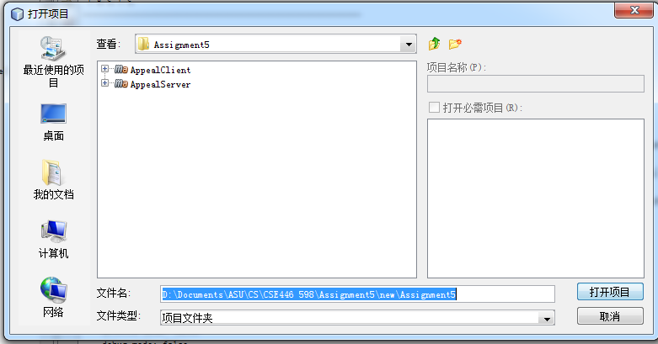

3. In the Project Column, double click on AppealServer, then double click on Source Package, com.mycompany.appealserver, and AppealResource.java.
. 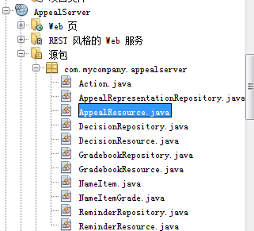

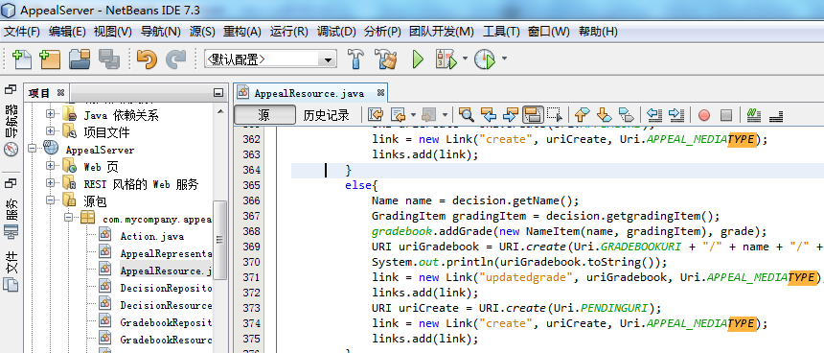

- Click on the green triangle button , or press F6, to run the server. Notice, these services should use GlassFish Server 3.1.2 as the server.

- After see the following page in your web explorer

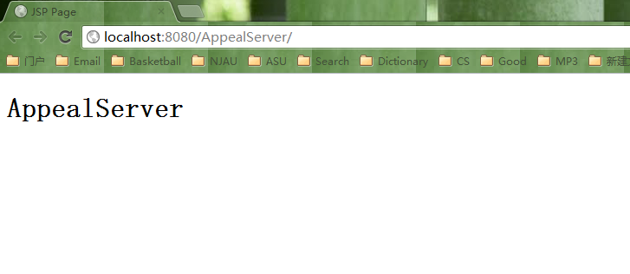
open App.java in the AppealClient, and then also click that green triangle button or directly press F6.
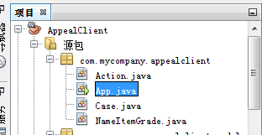

- Then in the output window, you will be able to see the output on both client and the server.
The sequence of the cases is: AbandonedCase, HappyCase, BadStart, ForgottenCase and BadId. On the client side, the cases are separated with “CaseName Start/End************************”, and the steps within each case are separated with “========================”. On the server side, there is no separation between cases, and steps are separated with “========================”.

- Steps in the AbandonedCase:
Step 1: Build appeal → Step 2: Send appeal to the server → Step 3: Delete the appeal and try to get the deleted appeal, finally get 404.

- Steps in the HappyCase:
Step 1: Build appeal → Step 2: Send appeal to the server → Step 3: Update the appeal → Step 4: Get the pending appeal → Step 5: Submit the appeal for process →.Step 6: Prof checks if there are any reminders, but find none (return 404) → Step 7: Prof retrieves one appeal, processes it and returned the generated decision to the server. Then he tries to retrieve another one, but get 404. → Step 8: Student retrieves the submitted appeal, and finds its status is processed → Step 9: Student retrieves the decision If the appeal is approved, he will go to Step 10 to retrieve the grade entry in the grade book, otherwise this case stops.

- BadStart
Step 1: Build appeal → Step 2: Send appeal to a wrong entry URI, get 404, and terminates.

- ForgottenCase
Step 1: Build appeal → Step 2: Send appeal to the server → Step 3: Update the appeal → Step 4: Get the pending appeal → Step 5: Submit the appeal for process → Step 6: After waiting for some time, student retrieves his submitted appeal. The server automatically generate a reminder and put it into the reminder repository for this unprocessed appeal. Step 7: Prof checks if there are any reminders, and retrieves the reminder. He retrieves the appeal containd in that reminder, processes it and returns the decision to the server. → Step 8: Prof checks if there are any unprocessed appeals in the submitted repository, and gets 404. → Step 9: Student retrieves the submitted appeal, and finds its status is processed → Step 10: Student retrieves the decision → Step 11 Student retrieve the grade if appeal is approved otherwise retrieves null.

- BadId
Step 1: Build appeal → Step 2: Send appeal to the server → Step 3: Update the appeal → Step 4: Get the pending appeal → Step 5: Submit the appeal for process → Step 6: After waiting for some time, student wants to retrieve his submitted appeal, but he uses a wrong id. Then he gets 404 and no reminder generated. Step 7: Prof checks if there are any reminders, and finds none. → Step 8: Prof checks if there are any unprocessed appeals. He retrieves the one in the submitted repository, processes it and returns the decision. → Step 9: Student retrieves the submitted appeal with the wrong id, and gets 404 again. The case stops.

7. There is some redundant information in the output of both server end and client end. I copied the outputs into file Highlighted Client Output.doc and Highlighted Server Output.doc. The different steps and important information are highlighted with different colors. Hopefully that will be helpful for the user to review the output.

